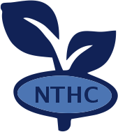 **NYAME TUMI HERBAL CHURCH**

*The best treatment of stroke*

Jei -krodua ( Mangoase ) Tel : **0555903044**

Dear sir/madam,

THE MEDICAL REPORT OF MR. CHARLES AMOAKO.

Mr. Charles Amoako who is an employee of your company has been admitted here for a while now. His illness was a challenging one but with the help of God , I have seen a significant change in his health after sometime of treatment .

The treatment is not fully done and as such, I will plead with you to give him four months to complete it and fully heal.

I hope my request will be granted .

Yours Faithfully ,

Isaac Dadzie

( 0555903044)